Name = Ahmad Nawaz
Registration Number = L1F23BSCS0099
(AI Lab 2)

2.4
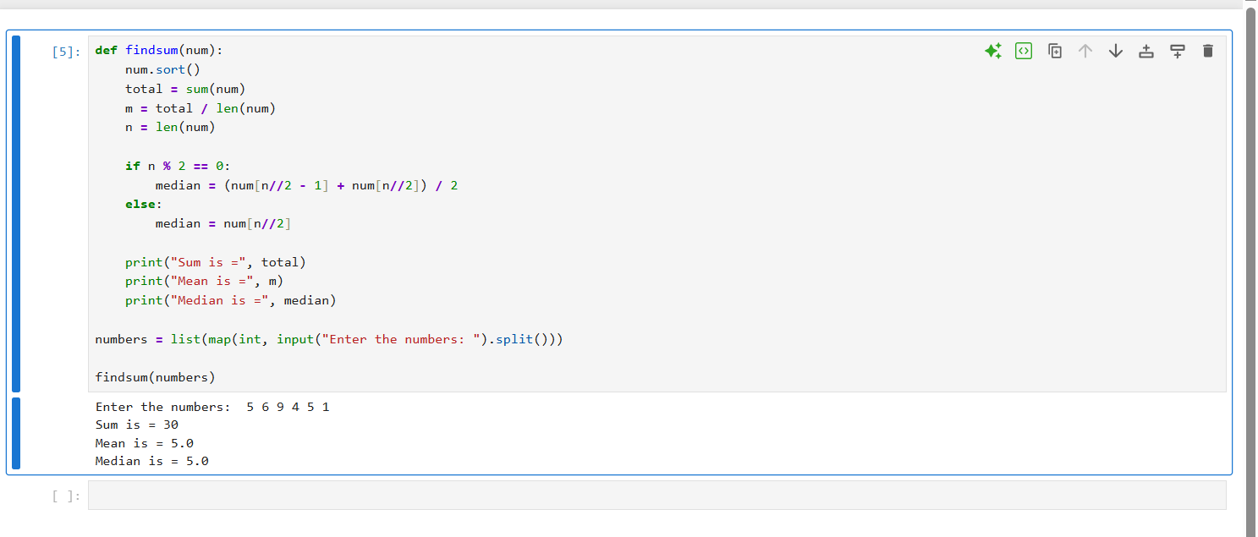
2.5
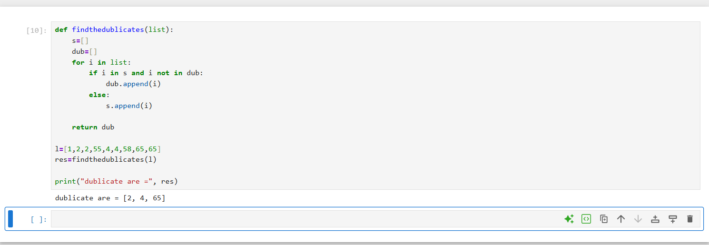

2.6
